**Ideation Phase**

**Define the Problem Statements**

|  |  |
| --- | --- |
| Date | 26 June 2025 |
| Team ID | LTVIP2025TMID32045 |
| Project Name | EduTutor AI: Personalized Learning with Generative AI and LMS Integration |
| Maximum Marks | 2 Marks |

**Customer Problem Statement EduTutor AI:**

In today’s fast-paced education system, students often face the challenge of understanding complex subjects without proper guidance. Many rely on online resources, but these are often generic, not personalized to the learner’s pace or style. Meanwhile, educators are overwhelmed with the repetitive task of creating and evaluating quizzes manually for every student.

EduTutor AI aims to solve this by offering a personalized AI tutor that provides:

* Concept explanations simplified for different age levels
* Grammar and language learning support in English and Hindi
* Automated quiz and test generation from PDFs and topics

This solution empowers students to learn at their own pace with clarity, and enables educators to scale personalized learning experiences without increased workload.

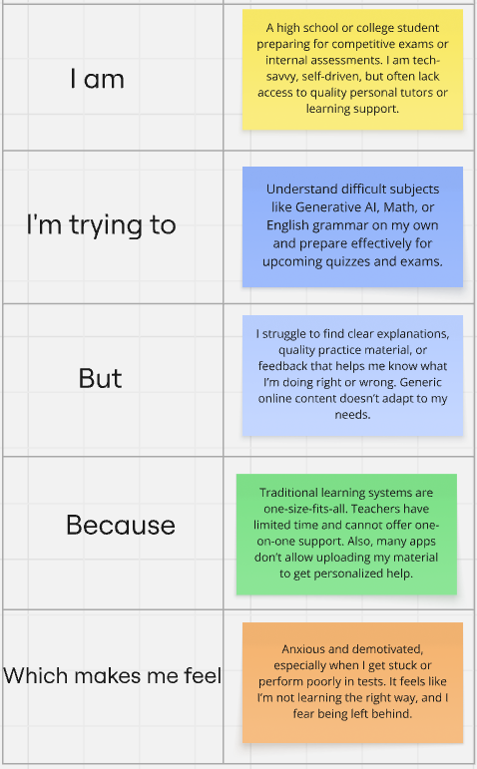

**Example:**

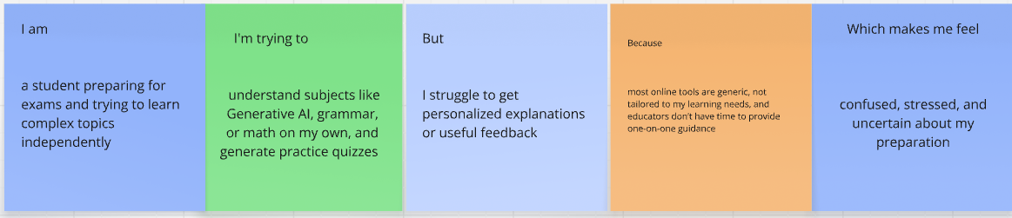

|  |  |  |  |  |  |
| --- | --- | --- | --- | --- | --- |
| **Problem Statement (PS)** | **I am (Customer)** | **I’m trying to** | **But** | **Because** | **Which makes me feel** |
| PS-1 | a high school student preparing for exams | understand difficult topics and revise efficiently | I can't grasp the concepts fully and get no feedback | online resources are generic and teachers are not always available | frustrated, confused, and unsupported |
| PS-2 | a teacher managing multiple students | generate personalized | I don’t have time to prepare and evaluate tests for each student | manual creation and review takes too much effort | overwhelmed and limited in my teaching impact |